Practical-15
Final Integration, Testing, Documentation, GitHub Submission, and Local Deployment
Theory
1. Are all pages properly linked and navigable?
Answer: The final homepage and administrator, student management and AJAX event modules opened successfully within practical15. Integrated navigation links were visible. The poster-upload page and every other route were not individually documented by new screenshots.
2. Are sessions, roles, validations, and database operations working end-to-end?
Answer: The administrator login opened a live MySQL-backed dashboard with 5 users, 41 students, 23 events and 7 registrations. AJAX GET returned a connected HTTP 200 event list. A logged-out attempt to open the admin page redirected to the login screen. A full Practical 15 re-test of each CRUD action was not captured.
3. Are security and accessibility checklists completed?
Answer: Unauthenticated access protection was verified by the login_required redirect. A responsive homepage was inspected at a 400 x 725 mobile viewport. The source archive contains a security/accessibility checklist, but a full manual accessibility audit, all mobile modules and penetration testing were not evidenced.
4. Is project documentation sufficient for installation and testing?
Answer: The project archive includes README.md, DEPLOYMENT.md, GITHUB_SUBMISSION.md, practical15.sql, a fresh-install SQL script, a test-report template and a security/accessibility checklist. These explain local XAMPP setup, tests and submission steps.
5. Is the project repository clean and properly committed?
Answer: A public StudentHub repository on GitHub showed a practical15 folder on the main branch and 42 commits in the captured view. The content of every commit, secret scanning and clean working-tree status were not independently verified.
Result:
The final StudentHub integration was demonstrated locally using XAMPP, PHP, MySQL and JavaScript. The homepage, authenticated admin dashboard, student management screen and AJAX GET event listing loaded. The login-required security redirect and a mobile-sized homepage were captured. GitHub displayed the practical15 folder. Poster-upload CRUD, complete accessibility testing and virtual-host deployment remain outside the screenshot evidence.
Evidence of Work (Screenshots)
The following original browser screenshots document the integration tests carried out for Practical 15. They are not simulated or reconstructed.

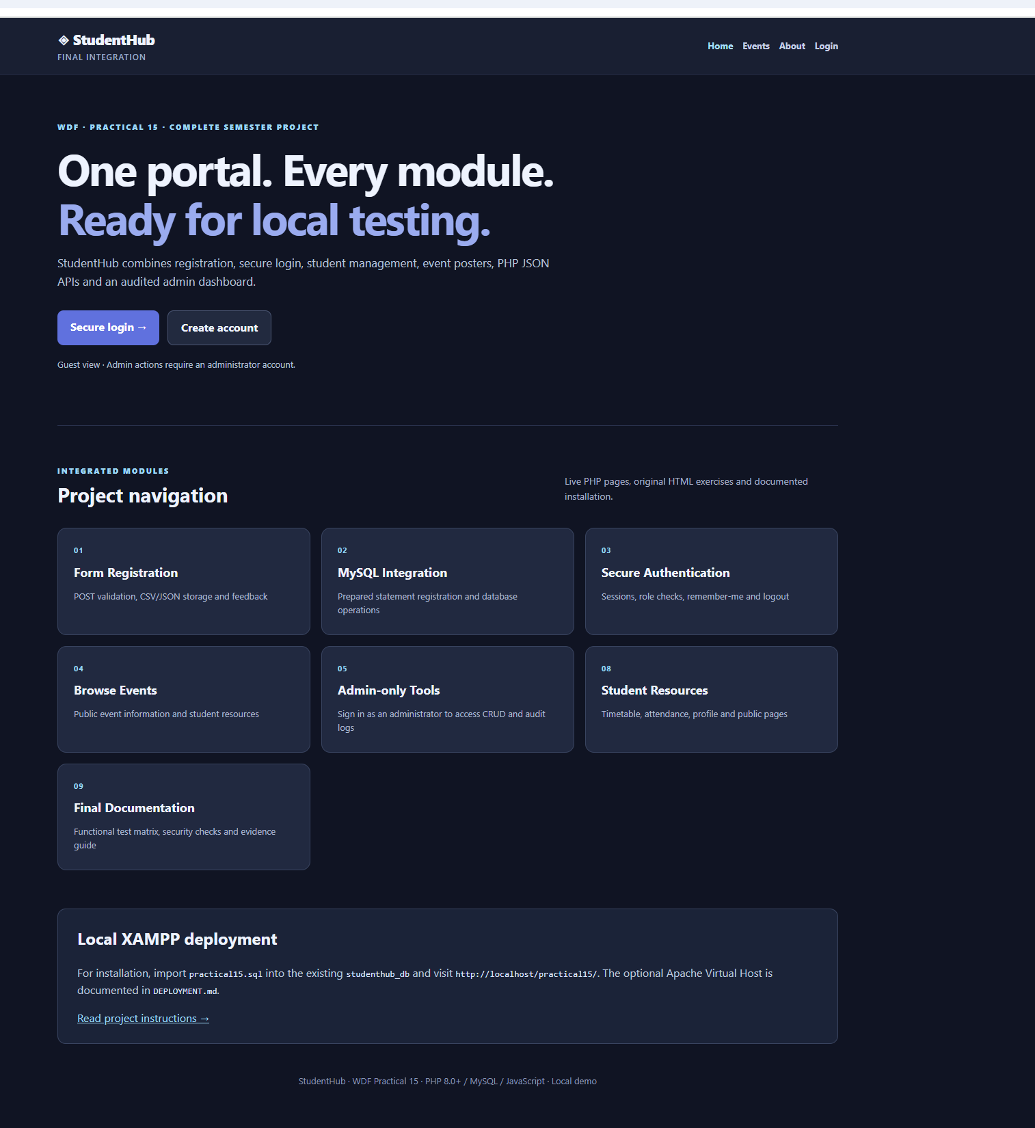
Figure 1: Final Integrated StudentHub Homepage and Project Navigation
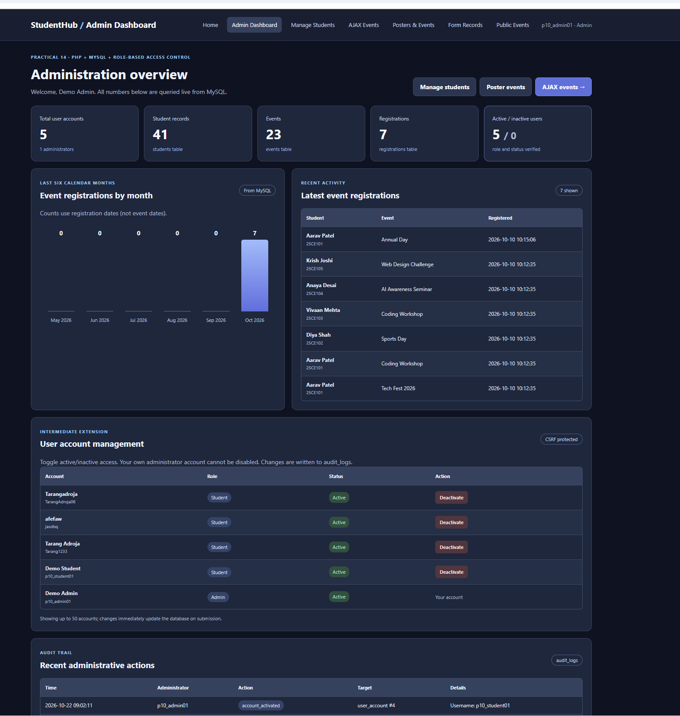
Figure 2: Integrated Admin Dashboard with Live MySQL Statistics

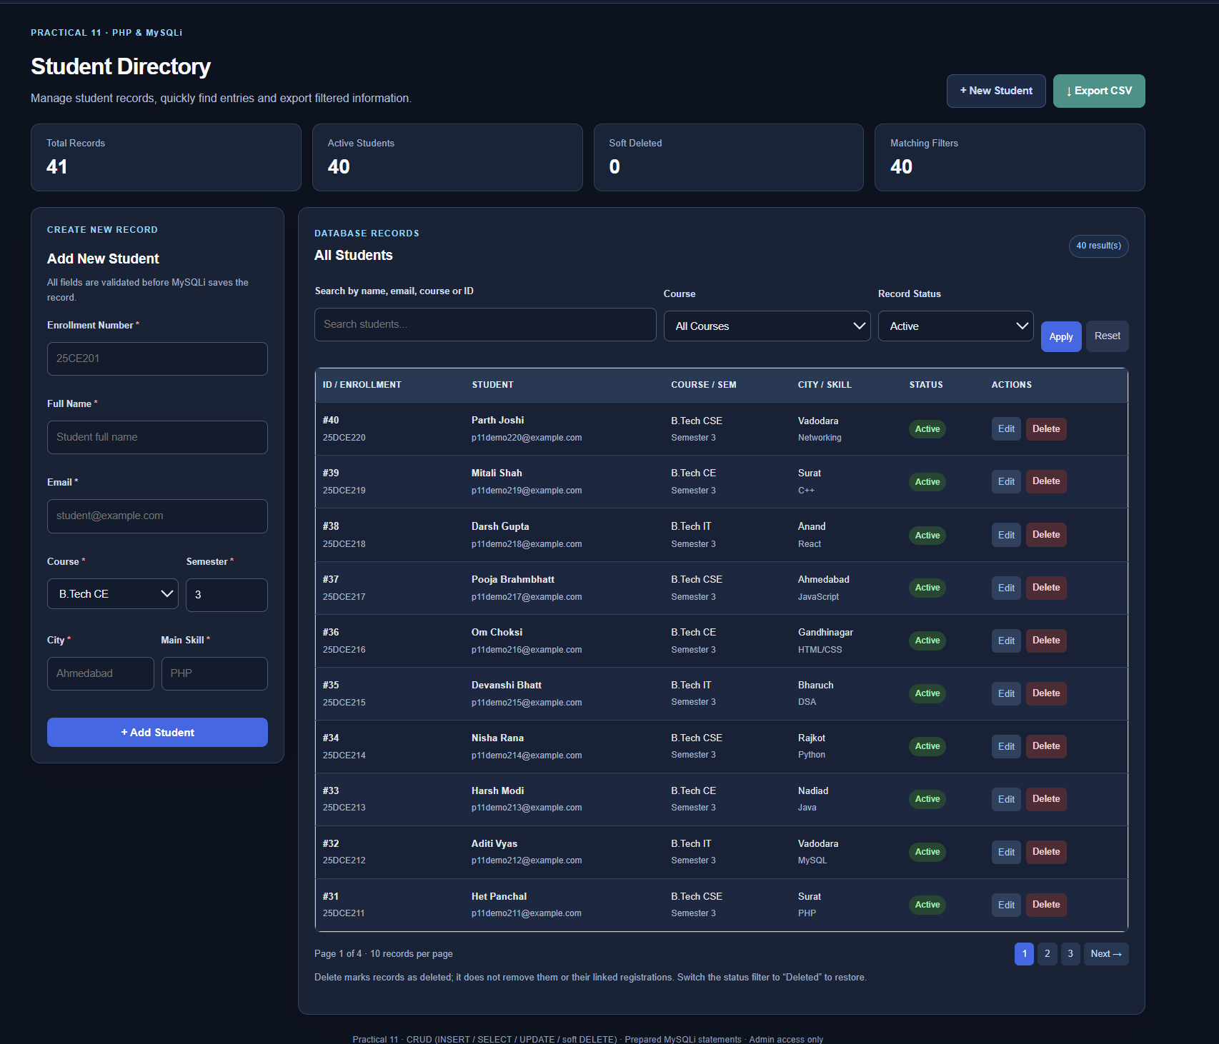
Figure 3: Student Management Module Integrated in Practical 15
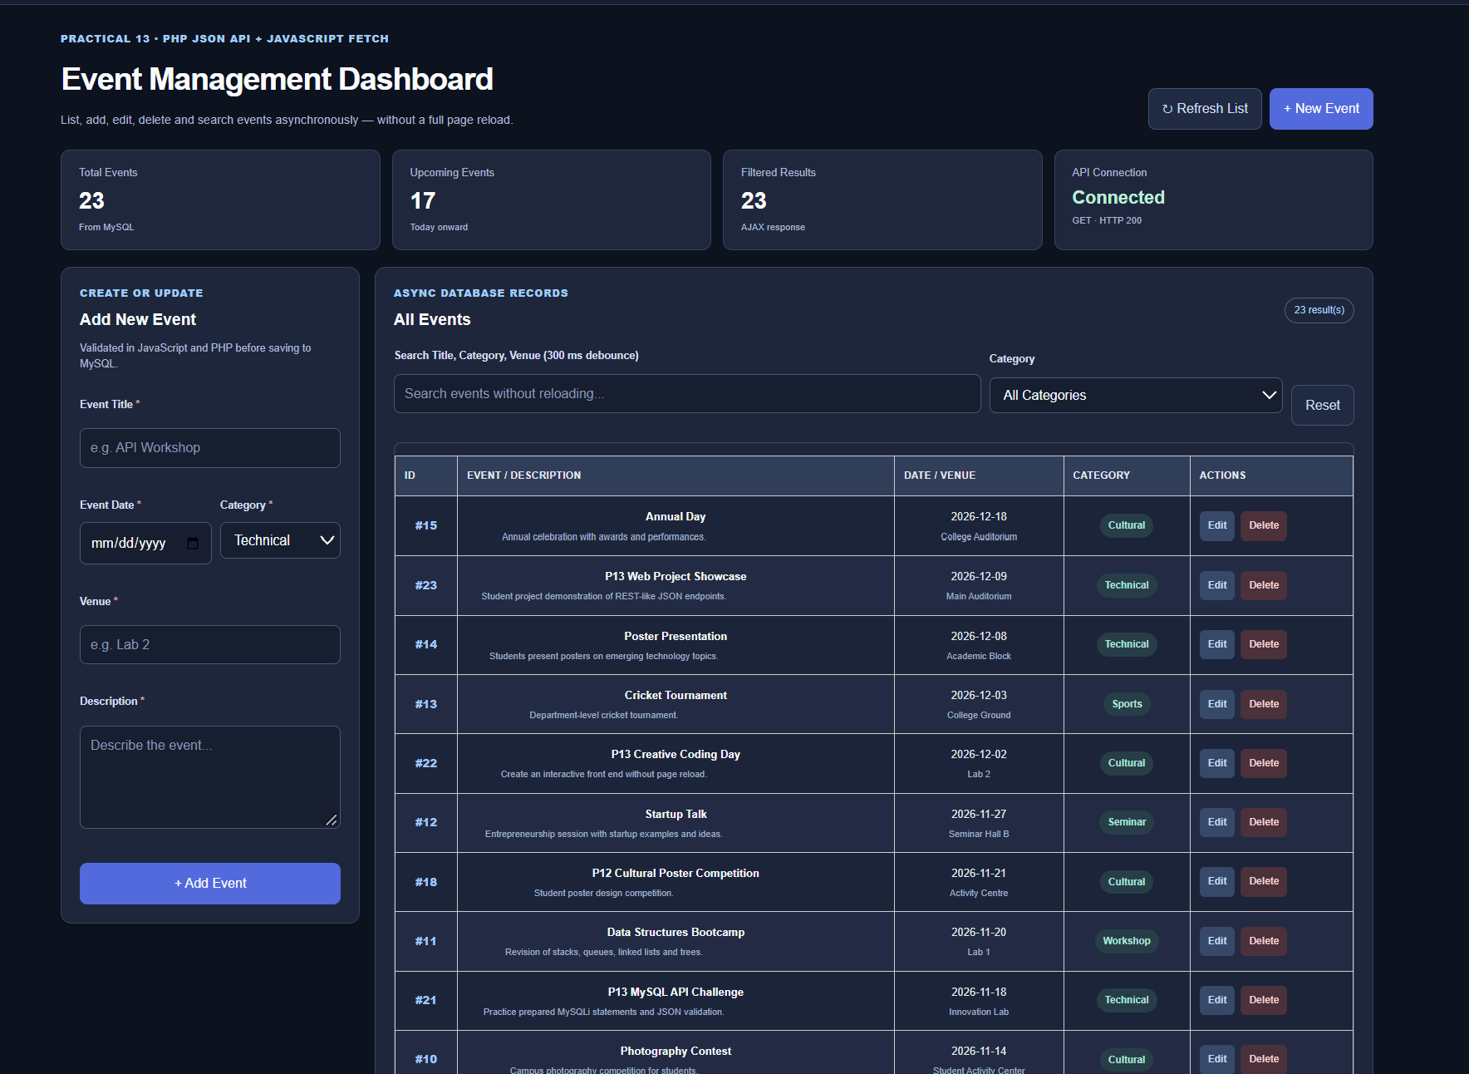
Figure 4: AJAX Event Dashboard Returns GET HTTP 200 and Event Records

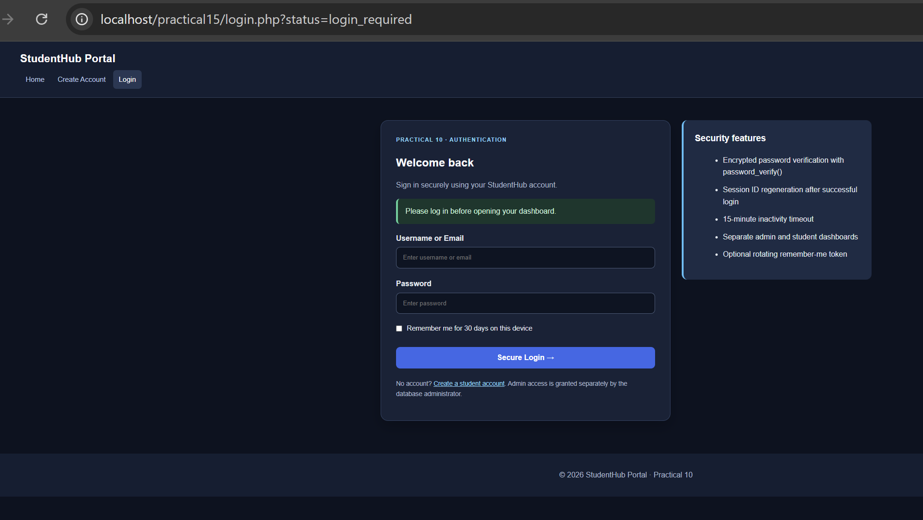
Figure 5: Unauthenticated Admin Visit Redirected to Login
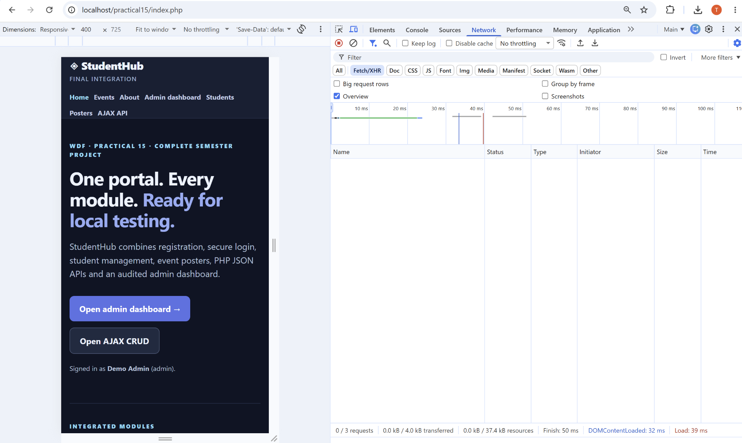
Figure 6: Responsive StudentHub Homepage Inspected at 400 px Width

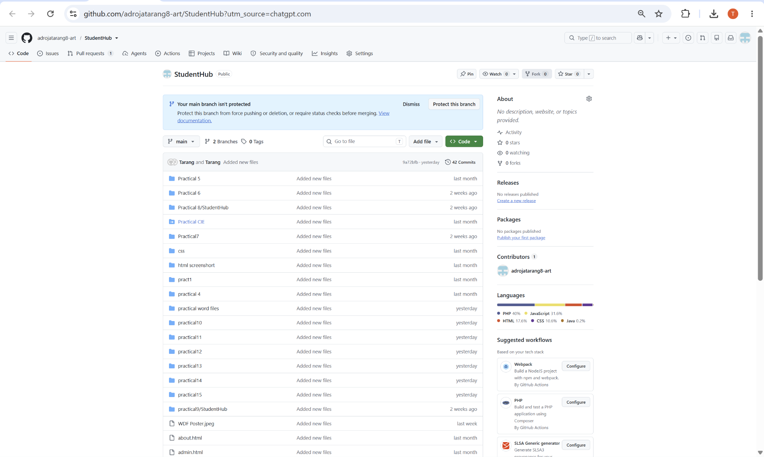
Figure 7: Public GitHub StudentHub Repository Lists practical15 Folder
A. GitHub Repository Link:
https://github.com/adrojatarang8-art/StudentHub

B. Challenges Faced:
• I corrected the initial localhost URL/folder access issue and opened the final index.php homepage.
• I logged in again within practical15 because an authenticated session from a previous practical was not sufficient evidence for the final module.
• I checked that the integrated dashboard, Student Directory and AJAX event screen loaded from the same StudentHub database.
• I verified that an unauthenticated admin request redirected to login.php?status=login_required.
• I used Chrome device emulation to inspect the homepage layout at a 400-pixel mobile width.
• I checked the GitHub repository listing for the uploaded practical15 folder and reviewed the documentation shipped with the project ZIP.
C. Learning Outcome:-
I learned to combine separate HTML, CSS, JavaScript, PHP and MySQL practical modules into one StudentHub application, verify integration routes and shared data, test session-based access protection, inspect responsive layout, organize installation and security documentation, and prepare a version-controlled GitHub submission. I also learned to distinguish tests directly observed in the browser from checks that still require manual execution.
Faculty Remarks:

